**CD-01 Service**

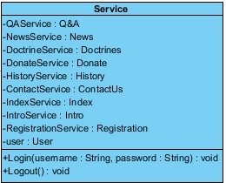

Service class for connect to controller.

**Method Description**

|  |  |  |  |  |
| --- | --- | --- | --- | --- |
| Name | Return type | |  | | --- | | **Parameter** | | |
| **Name** | |  | | --- | | **Type** | |
| Login | Void | Username  Password | String  String | This method task 2 parameter: input username and password |
| Logout | Void | - | - | This method clear session off to system |

**CD-02 Q&A**

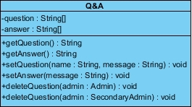

Q&A class for update question and answer

**Method Description**

|  |  |  |  |  |
| --- | --- | --- | --- | --- |
| Name | Return type | |  | | --- | | **Parameter** | | |
| **Name** | |  | | --- | | **Type** | |
| getQuestion | String | - | - | This method use for show question in interface |
| getAnswer | String | - | - | This method use for show Answer in interface |
| setQuestion | void | Name  message | String  String | This method use for create question create by user |
| setAnswer | void | message | String | This method use for create answer create by admin |
| deleteQuestion | void | admin | Admin | This method use for delete question by admin |
| deleteQuestion | void | admin | Secondary | This method use for delete question by secondary admin |

**CD-03 News**

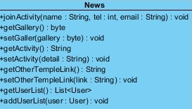

News class for update activity and picture all about News

**Method Description**

|  |  |  |  |  |
| --- | --- | --- | --- | --- |
| Name | Return type | |  | | --- | | **Parameter** | | |
| **Name** | |  | | --- | | **Type** | |
| joinActivity | void | name  tel  email | String  Int  String | This method use for register to join activity |
| getGallery | byte | - | - | This method use for show Gallery in interface |
| setGallery | void | gallery | byte | This method use for update Gallery |
| getActivity | String | - | - | This method use for show Activity in interface |
| setActivity | void | detail | String | This method use for update Activity |
| getOtherTempleLink | String | - | - | This method use for show link of other temple in interface |
| setOtherTempleLink | void | link | String | This method use for set link of other temple |
| getUserList | List<User> | - | - | This method use for show list of user that join activity |
| addUserList | void | user | User | This method use for add list of user that join activity |

**CD-04 Donate**

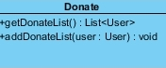

Donate class for show and add list of donate

**Method Description**

|  |  |  |  |  |
| --- | --- | --- | --- | --- |
| Name | Return type | |  | | --- | | **Parameter** | | |
| **Name** | |  | | --- | | **Type** | |
| getDonateList | List<User> | - | - | This method use for show list of donate |
| addDonateList | void | user | User | This method use for add list of donate |

**CD-05 Doctrines**

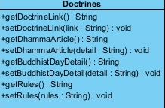

Doctrines class for update and show doctrine link, Dharma article, day of Buddhist, rules

**Method Description**

|  |  |  |  |  |
| --- | --- | --- | --- | --- |
| Name | Return type | |  | | --- | | **Parameter** | | |
| **Name** | |  | | --- | | **Type** | |
| getDoctrineLink | String | - | - | This method use for show doctrine link |
| setDoctrineLink | void | link | String | This method use for set doctrine link |
| getDhammaArticle | String | - | - | This method use for show Dharma article |
| setDhammaArticle | void | detail | String | This method use for set Dharma article |
| getBuddhistDayDetail | String | - | - | This method use for show day of Buddhist in calendar |
| setBuddhistDayDetail | void | detail | String | This method use for set day of Buddhist in calendar |
| getRules | String | - | - | This method use for show rules in interface |
| setRules | void | rules | String | This method use for set rules in interface |

**CD-06 Registration**

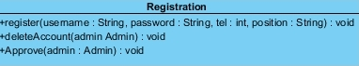

Registration class use for register account for use web

**Method Description**

|  |  |  |  |  |
| --- | --- | --- | --- | --- |
| Name | Return type | |  | | --- | | **Parameter** | | |
| **Name** | |  | | --- | | **Type** | |
| register | void | username  password  Tel  position | String  String  Int  String | This method use for secondary admin register. |
| deleteAccount | void | admin | Admin | This method use for delete account of secondary admin so delete by admin |
| Approve | void | admin | Admin | This method use for confirm registration so confirm by admin |

**CD-07 Intro**

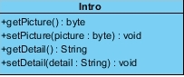

Registration class use for register account for use web

**Method Description**

|  |  |  |  |  |
| --- | --- | --- | --- | --- |
| Name | Return type | |  | | --- | | **Parameter** | | |
| **Name** | |  | | --- | | **Type** | |
| getPicture | byte | - | - | This method use for show picture in Intro page |
| setPicture | void | picture | byte | This method use for update picture |
| getDetail | String | - | - | This method use for show detail in Intro page |
| setDetail | void | detail | String | This method use for update detail |

**CD-08 Index**

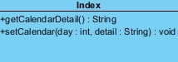

Index class use for show calendar

**Method Description**

|  |  |  |  |  |
| --- | --- | --- | --- | --- |
| Name | Return type | |  | | --- | | **Parameter** | | |
| **Name** | |  | | --- | | **Type** | |
| getCalendar | String | - | - | This method use for show calendar |
| setCalendar | void | Day  detail | Int  String | This method use for update calendar |

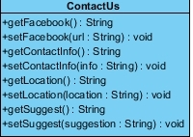**CD-09 ContactUs**

ContactUs class use for show detail about how do you can contact us.

**Method Description**

|  |  |  |  |  |
| --- | --- | --- | --- | --- |
| Name | Return type | |  | | --- | | **Parameter** | | |
| **Name** | |  | | --- | | **Type** | |
| getFacebook | String | - | - | This method use for show link of facebook |
| setFacebook | void | url | String | This method use for update link of facebook |
| getContactInfo | String | - | - | This method use for show description of info |
| setContactInfo | void | Info | String | This method use for update description of info |
| getLocation | String | - | - | This method use for show location of temple so show by google map |
| setLocation | void | Location | String | This method use for update location. |
| getSuggest | String | - | - | This method use for show suggest of travel to temple |
| setSuggest | void | suggestion | String | This method use for update suggest of travel to temple |

**CD-10 History**

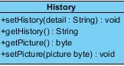

History class use for show history of temple

**Method Description**

|  |  |  |  |  |
| --- | --- | --- | --- | --- |
| Name | Return type | |  | | --- | | **Parameter** | | |
| **Name** | |  | | --- | | **Type** | |
| setHistory | void | detail | String | This method use for update history of temple |
| getHistory | String | - | - | This method use for show history of temple |
| getPicture | byte | - | - | This method use for show picture |
| setPicture | void | picture | byte | This method use for update picture. |